There are a number of situations in software engineering when it is important for disparate groups of programmers to agree to a "contract" that spells out how their software interacts. Each group should be able to write their code without any knowledge of how the other group's code is written. Generally speaking, interfaces are such contracts.
In the Java programming language, an interface is a reference type, similar to a class that can contain only constants, method signatures, default methods, static methods, and nested types. Method bodies exist only for default methods and static methods. Interfaces cannot be instantiated—they can only be implemented by classes or extended by other interfaces.
Interfaces serve as an outline of the class ‘implementing it'(inherit). The members declared in it are public, static by default.
Hence we can have a constructor for an abstract class but not for the interface as it contains static members.
Example 1:
interface Calculation {
int add(int a, int b);
int multiply(int a, int b);
}
class CalculateImplementation implements Calculation {
@Override
public int add(int a, int b) {
return a + b;
}
@Override
public int multiply(int a, int b) {
return a * b;
}
void disp() {
System.out.println(add(5, 6));
System.out.println(multiply(5, 6));
}
}
public class Test {
public static void main(String[] args) {
CalculateImplementation c = new CalculateImplementation();
c.disp();
}
}
Example 2: interface with default method
interface Calculation {
int add(int a, int b);
int multiply(int a, int b);
default void disp() {
System.out.println("Add: " + add(5, 6));
System.out.println("Multiply: " + multiply(5, 6));
}
}
class CalculateImplementation implements Calculation {
@Override
public int add(int a, int b) {
return a + b;
}
@Override
public int multiply(int a, int b) {
return a * b;
}
}
public class Test {
public static void main(String[] args) {
Calculation c = new CalculateImplementation();
c.disp();
}
}
Example 3:
//Interface declaration:by first user
interface Drawable {
void draw();
}

//Implementation: by second user
class Rectangle implements Drawable {
public void draw() {
System.out.println("drawing rectangle");
}
}

class Circle implements Drawable {
public void draw() {
System.out.println("drawing circle");
}
}

//Using interface: by third user
class Test {
public static void main(String args[]) {
Drawable d = new Circle();// In real scenario, object is provided by method e.g. getDrawable()
d.draw();
}
}
Interfaces, as we discussed earlier, is the outline or the prototype for the classes implementing it. Multiple Inheritance is not allowed in Java due to problems such as the diamond problem which causes the crashing of applications.
Interfaces are used to perform multiple inheritances which can be seen in the following example.
As we see, in the project we have multiple interfaces which are implemented by Person class because multiple inheritance does not create any ambiguity in interfaces.
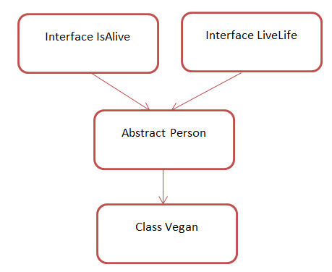
Example 3:
interface IsAlive {
public void breathe();
}
interface LiveLife {
public void message();
}
abstract class Person implements IsAlive, LiveLife {
public void speak() {
System.out.println("Shares his/her thoughts.");
}
@Override
public void breathe() {
System.out.println("be alive; remain living. ");
}
@Override
public void message() {
System.out.println("life is a journey, keep moving and meet new people.");
}
public abstract void eat();
}
class Vegan extends Person {
@Override
public void eat() {
System.out.println("Eats vegan food");
}
}
public class Test {
public static void main(String[] args) {
Person john = new Vegan();
john.breathe();
john.eat();
john.speak();
john.message();
}
}

